11.05
Closed-Loop Repair
Process Design & AMOS Configuration Document
Purpose
This Process Design document is provided to Key-Users to record their key decisions regarding the AMOS Process design and the required AMOS configuration.
It is updated throughout the Project Definition Phase and used as the baseline for the Final Acceptance prior to Go-Live
Revision
Author, Name | Date | Notes
Paulo Reuter Perine | 01.06.2024 | First version

Table of Contents
1. Process Overview & Objectives 3
2. Regulatory References 3
3. Definitions & Glossary 3
4. Process Tasks 3
5. Process Flow 5
6. Process Design Questions 6
7. Data Source Mapping 7
8. Other Software Used 7
9. AMOS Configuration 7
a. Process specific configuration programmes 7
b. Basic Data 7
c. Parameters 7
d. Workflows 7
e. Scheduled Tasks 8
f. API’s & Interfaces 8
10. UAT Guidance 8
11. Annex – Additional Info 9

Process Overview & Objectives
Process General Description:
This procedure delineates the sequential steps for performing maintenance on a component outside of a shop environment, typically during aircraft maintenance. The process encompasses various stages, including identifying the need for component maintenance, deciding whether to remove the component for maintenance, executing the necessary repairs and inspections, reinstalling the component (if removed), releasing the component, and optionally issuing a new certificate.
Main Process Objective (Outputs & Outcomes):
The main objective of this process is to enable component maintenance to be conducted at the aircraft location, eliminating the need to physically transport the part to the shop. Instead, qualified shop personnel visit the aircraft and execute a Component Workpackage (CMWP). This approach allows for component maintenance in a non-shop environment while adhering to the same steps outlined in the 11.04 Component Maintenance process regarding execution of the work.

Regulatory References
There is no worldwide authority regulation applicable to this process, but local regulations apply. Please check:
- Local civil aviation regulation.
- Annex I (Part-M) - SECTION A — TECHNICAL REQUIREMENTS - SUBPART E — COMPONENTS.
- Annex I - SECTION A — TECHNICAL REQUIREMENTS - SUBPART K — PARTS AND APPLIANCES
- Part-145 EASA.
- Repair Station Operators (Part 145) from FAA.

Definitions & Glossary
Key-Words | Explanation
APN | AMOS Program Number.
Closed Loop | Means the part is physically removed from the aircraft to perform a repair but there is no label booking for removal/installation.
CMM | Component Maintenance Manual
CMWP | Component Maintenance Workpackage created in AMOS.
EASA | European Union Aviation Safety Agency
FAA | United States Federal Aviation Administration
Turnaround | Means the part is physically removed from the AC and a label booking is created to record the removal.
WP | Aircraft Workpackage

Process Tasks
Business Process Task / Actions / Activities:
- Perform component maintenance of part on A/C under check: When performing maintenance at the aircraft and a component repair using CMM instructions is needed, you must decide if Label Booking is necessary or not, before performing maintenance at the aircraft. Then you must continue to execute the work on the component and release it once the work is completed. Based on your decision about the label booking you must proceed to reinstall the component.
- Manage release/certification of parts: Once the component maintenance is completed, you must release the component and, if applicable, you can issue a new certificate for the component.

INPUT | CONCURRENT | OUTPUT
- 08.02 – Performing Maintenance: Identify the need to have a component maintenance to be executed at the aircraft. | - 08.04 – Parts Removal & Installation: Decide if the component needs to be label booked out of the aircraft to perform maintenance.  - 09.04 – Repair and Exchange: If the unit is label booked, issue a CMWP.  - 11.04 – Component Maintenance: Execute the component maintenance.  - 11.03 – Shop Planner: Plan the execution of CMWP at aircraft if known in advance. | - 11.06 – Component Release: Release the component after maintenance is performed.  - 08.04 – Parts Removal and Installation: Reinstall the component.

Process Flow
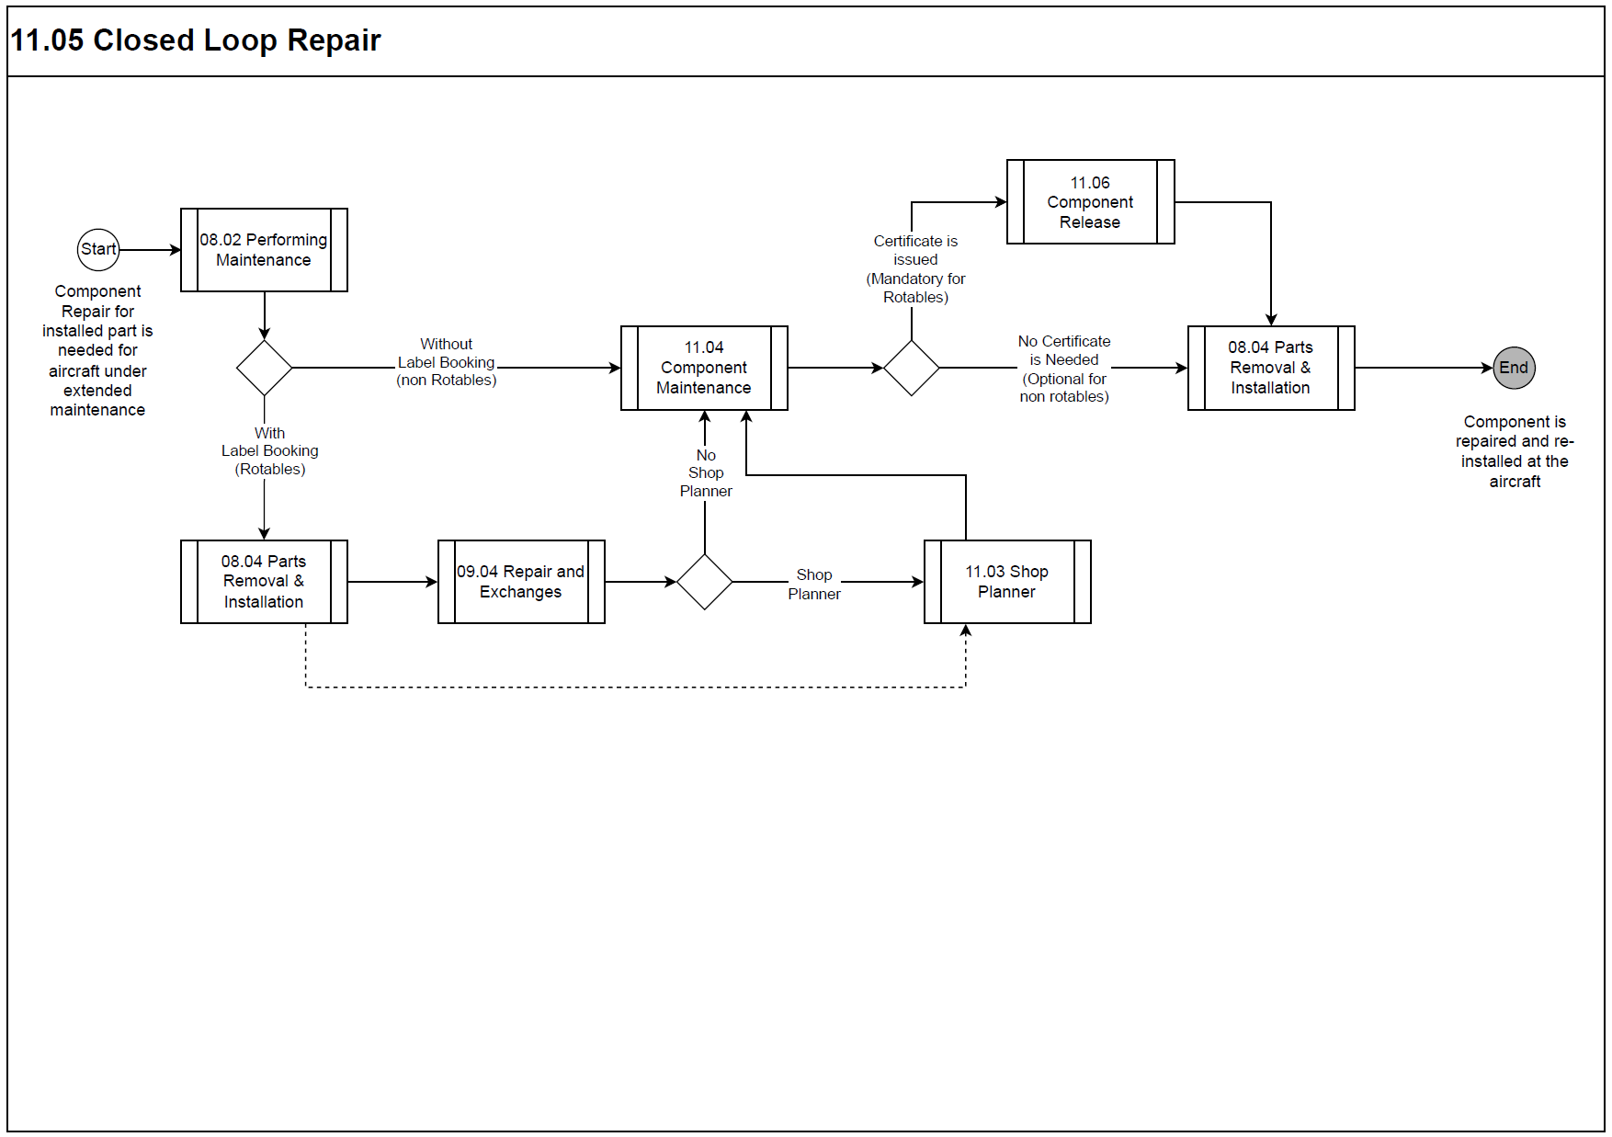

Process Design Questions
# | Question | Answer
01 | Do you currently have Closed Loop process in your company?
02 | How do you manage Closed Loop maintenance in your organization?
03 | Do you record the removal and installation of a consumable repairable being repaired?
04 | Do you record the removal and installation of a rotable component being repaired?
05 | Do you issue a certificate when performing component maintenance in a consumable repairable unit?
06 | Do you issue a certificate when performing component maintenance in a rotable component?
07 | Do you have any part or component that should not be allowed to use the Closed Loop process?

Data Source Mapping
Data Sources | Description | Volume / Manual / Automatic / Static / Dynamic
-/- | -/- | -/-

Other Software Used
Other Software | Used by: | Description
-/- | -/- | -/-

AMOS Configuration

Process specific configuration programmes
AMOS APN | Notes
-/- | -/-

Basic Data
Basic Data Table | Notes
-/- | -/-

Parameters
Parameter Code | Parameter Name | Notes
1868 | Component Workpackage Component Release Configuration | The string value of this parameter controls whether a certificate is required before releasing apart from APN 3075. | String Y;Y  Integer 0  Float 1.00

Workflows
Workflow Number | Workflow Name | Workflow Setup Notes
505 | Component Workpackage Save (Pre-Save) | This work-flow ca be used to restrict which component and parts can use the Closed-Loop process by using part special.

Scheduled Tasks
Scheduled Task Reference | Frequency | Notes
-/- | -/- | -/-

API’s & Interfaces
Reference | Direction | Trigger | Frequency
-/- | -/- | -/- | -/-

UAT Guidance
Test case number | Test case description | Required data | Required resources
-- | With Label Book scenario | -/- | -/-
01 | During execution of a WP in a hangar, remove a component that requires maintenance by shop mechanic via label booking. | Managed Aircraft WP. | Aircraft mechanic
02 | Create a CMWP from APN 1431 Repair Administration. | -/- | Aircraft mechanic
03 | Plan the execution of the component maintenance at the hangar. | -/- | Shop planner
04 | Execute the component repair. | -/- | Shop Mechanic
05 | Release the component and issue a new certificate. | -/- | Shop Mechanic
06 | Reinstall the component via label booking. | -/-
-- | Without Label Booking scenario | -/- | -/-
07 | During execution of a WP in a hangar, remove physically the component that requires maintenance by shop mechanic. | Non-managed Aircraft WP. | Aircraft mechanic
08 | Create a CMWP from APN 58 View/Edit Workpackage. | -/- | Aircraft mechanic
09 | Execute the component repair. | -/- | Shop Mechanic
10 | Release the component and issue a new certificate.  Note: the issuance of the component release is optional. | -/- | Shop Mechanic
11 | Reinstall physically the component. | -/- | Aircraft mechanic

Annex – Additional Info
-/-

